simge, sembol, logo, amblem, ticari marka içeren bir resim

Açıklama otomatik olarak oluşturuldu

**T.C**

**Piri Reis University**

**Faculty of Economics and Administrative Sciences Management Information Systems**

**Assignment Report**

My Database Topic = using addEventListener and jQuery

Student Name = Naci Eren

Student Surname = Kılıç

Date of Report = 28.05.2023

Lesson = ISE226 Advanced Web Design

Department = Information Systems Engineering

University = Piri Reis University

**Summary of My Work**

In this project, I examined the differences between addEventListener and jQuery. I made 2 html pages with radio buttons, selection menu, text box, checkboxes, input tag buttons and text inside a div, span, or paragraph tag. Although 2 of them have the same features, one was made with addEventListener and the other with jQuery.

**addEventListener.html**

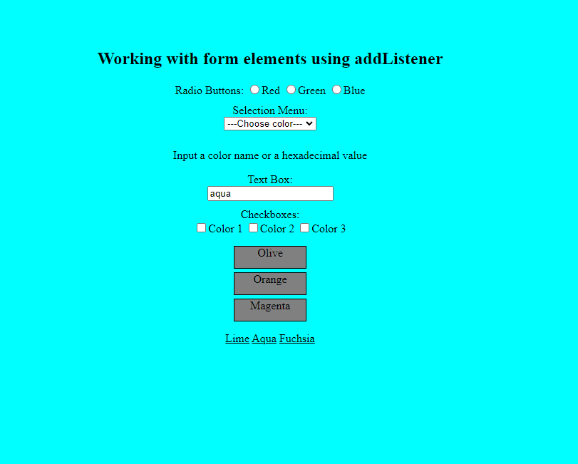

metin, ekran görüntüsü, yazılım, ekran, görüntüleme içeren bir resim

Açıklama otomatik olarak oluşturuldu

**In the style section, I have designed the black lines around the buttons and the button backgrounds in these parts here.**

metin, ekran görüntüsü, menü içeren bir resim

Açıklama otomatik olarak oluşturuldu

**I have designed the form elements in this section. In this section, I created the order, shapes, text types, types, classes and values of radio buttons, selection menu, text box, checkboxes, input tag buttons and text inside a div, span, or paragraph tag plugins.**

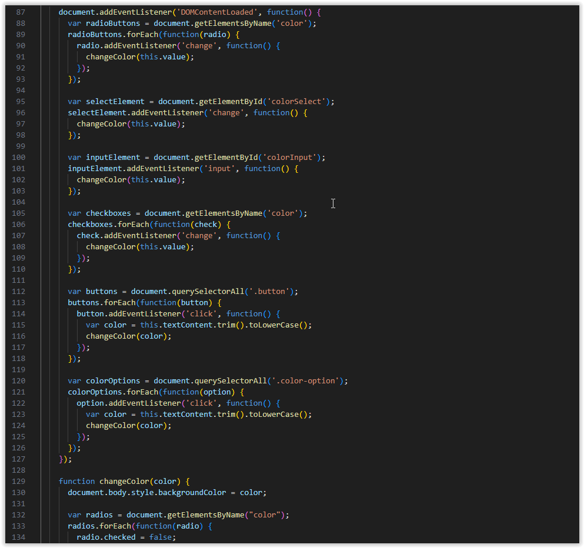

metin, ekran görüntüsü, yazılım, multimedya yazılımı içeren bir resim

Açıklama otomatik olarak oluşturuldu

**In this section, I have created separate functions where radio buttons, selection menu, textbox, checkboxes, input tag buttons and text inside a div, span, or paragraph tag form elements execute the values I have assigned to them.**

**jQuery.html**

**metin, ekran görüntüsü, yeşil, tasarım içeren bir resim

Açıklama otomatik olarak oluşturuldu**

metin, ekran görüntüsü, yazılım, ekran, görüntüleme içeren bir resim

Açıklama otomatik olarak oluşturuldu

**In the style section, I have designed the black lines around the buttons and the button backgrounds in these parts here.**

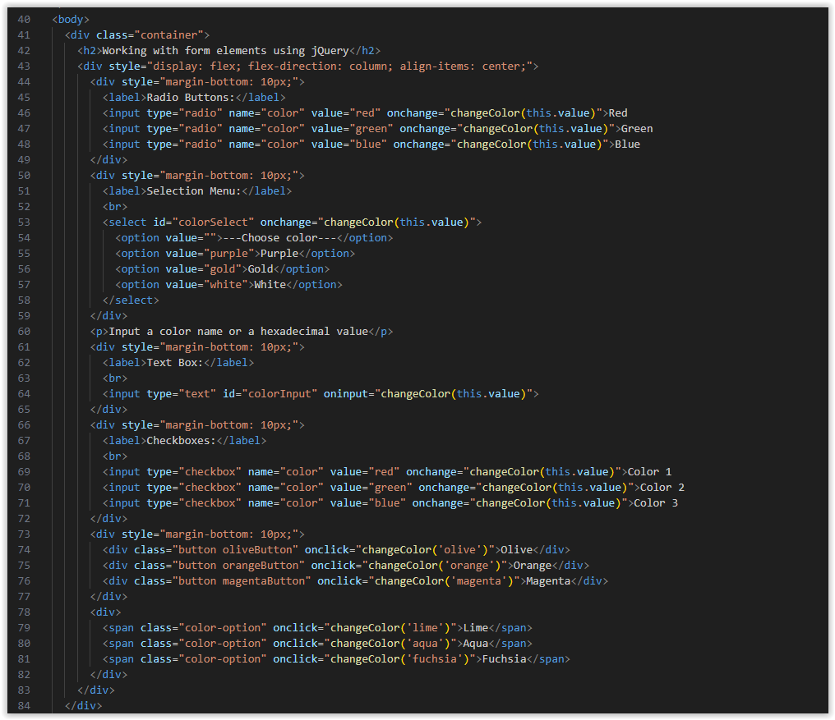

**I have designed the form elements in this section. In this section, I created the order, shapes, text types, types, classes and values of radio buttons, selection menu, text box, checkboxes, input tag buttons and text inside a div, span, or paragraph tag plugins.**

metin, ekran görüntüsü, ekran, görüntüleme, yazılım içeren bir resim

Açıklama otomatik olarak oluşturuldu

**In this section, I created a functionon that runs the values I assigned to the radio buttons, the selection menu, the text box, the check boxes, the input tag buttons, and the text inside a div, span, or paragraph tag form elements. It was not as long as the other method. I was able to end it in a shorter and clearer way.**